CINERESERVE

Proposed Solution
IDEATION PHASE • MOVIE TICKET BOOKING PLATFORM

1. Executive summary
CineReserve is a proposed web-based movie ticket booking platform that guides users from discovering a film to receiving a booking confirmation. It prioritises clarity, responsive layouts, reliable seat-state handling and accessible booking records.

2. Solution overview
Capability | Proposed behaviour | User benefit
Movie discovery | Browse/search movie cards with poster, genre, language, duration and synopsis. | Easier shortlisting.
City and cinema | Choose city, cinema and showtime. | Clear location and schedule context.
Seat selection | Seat map distinguishes available, selected and unavailable seats. | Fewer selection mistakes.
Booking summary | Show seats, fees, discount and total before checkout. | Transparent pricing.
Checkout | Use configured provider/sandbox or clearly labelled demo simulation. | No confusion about real transactions.
Digital ticket | Display booking ID and ticket/QR information where supported. | Easy confirmation retrieval.
My Bookings | List upcoming and previous bookings and status. | Convenient repeat access.
Admin tools | Manage movies, cinemas, showtimes and bookings with role checks. | Controlled catalogue updates.

3. Functional requirements
ID | Requirement | Priority | Acceptance check
FR-01 | Browse and search movie catalogue. | Must | Results match query and empty states are clear.
FR-02 | Select city, cinema and showtime. | Must | Selected show remains visible during seat selection.
FR-03 | Display and enforce seat availability. | Must | Unavailable seats cannot be selected.
FR-04 | Expire abandoned seat holds. | Must | Expired holds release seats.
FR-05 | Show price breakdown. | Must | Total matches line items and discounts.
FR-06 | Create booking after demo/sandbox checkout success. | Must | Booking appears on confirmation and My Bookings.
FR-07 | View ticket and booking details. | Must | Only authorised users can view private bookings.
FR-08 | Admin can manage movies and showtimes. | Should | Admin routes require role authorisation.
FR-09 | Apply coupons with clear validation. | Could | Invalid/expired codes are rejected with an explanation.

4. Customer journey
Stage | User action | System response
Discover | Search or browse movies. | Return relevant movie cards and details.
Compare | Choose cinema and showtime. | Display available show options.
Select | Choose seats. | Validate availability and hold seats temporarily.
Confirm | Review total and checkout. | Validate price and payment/demo status.
Receive | Open ticket confirmation. | Show booking ID and My Bookings entry.

5. Non-functional goals
Area | Proposed standard
Usability | Consistent navigation, clear labels, helpful errors and responsive layouts.
Performance | Optimise images, filter/paginate large catalogues and avoid unnecessary requests.
Security | Validate server input, hash passwords and enforce ownership checks.
Reliability | Revalidate seats server-side and prevent concurrent double-booking.
Accessibility | Keyboard access, meaningful labels, contrast and non-colour-only seat states.
Maintainability | Separate UI, routes, controllers, services and models; document setup.

6. MVP and future enhancements
MVP / first release | Later enhancement
Movie catalogue, search and filters | Personalised recommendations.
City/cinema/showtime selection | Location-aware suggestions with permission.
Seat map and temporary holds | Group booking assistance.
Booking summary and demo/sandbox checkout | Production payment provider and verified refunds.
Ticket view and My Bookings | Email/SMS notifications and wallet integrations.
Admin catalogue management | Analytics based on actual usage data.

7. Risks and mitigations
Risk | Mitigation
Two users select same seat | Server-side holds and final availability checks.
Payment state is unclear | Separate pending/success/failed states; label demo behaviour.
Unauthorised booking access | Verify identity and booking ownership on every private endpoint.
Out-of-date showtimes | Use an authoritative database and revalidate before checkout.
Scope grows too quickly | Complete MVP before optional integrations.

8. Illustrative MVP effort allocation
Planning illustration only, not actual time tracking.
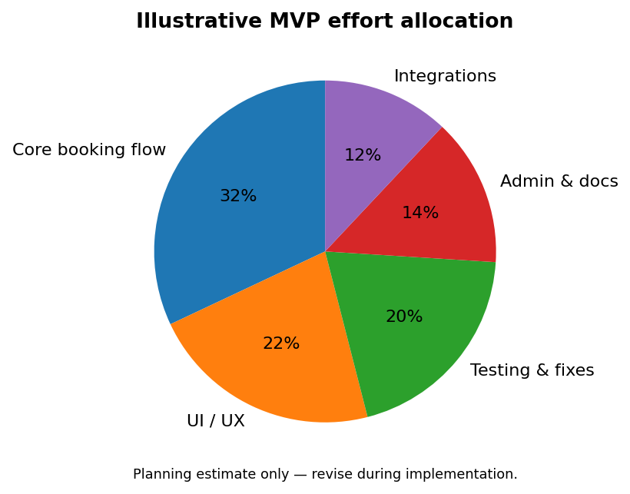

9. Definition of done
- Core booking flow works from movie selection to confirmation.
- Seat holds expire and concurrency scenarios are tested.
- Loading, error and empty states are designed.
- Authentication, role access and booking ownership are tested.
- README documents setup, environment variables and test commands.
- Demo payments are clearly labelled; no false real-payment claims.

